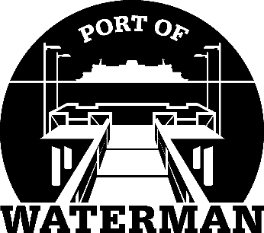

Port of Waterman Meeting Agenda

January 20, 2026

- Review/Approve Agenda

- Swear In Commissioner Acoba

- Review/Approve Prior Meeting Minutes

- Review/Approve Auditor’s Report

- Review Financial Statement

Old Business:

- Maintenance Update

New Business:

- Commissioner District Reports

