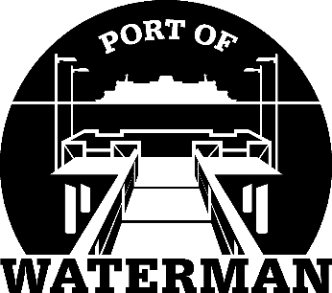

Port of Waterman Meeting Agenda

December 15, 2025

- Review/Approve Agenda

- Review/Approve Prior Meeting Minutes

- Review/Approve Auditor’s Report

- Review Financial Statement

Old Business:

- Maintenance Update

New Business:

- Commissioner District Reports

