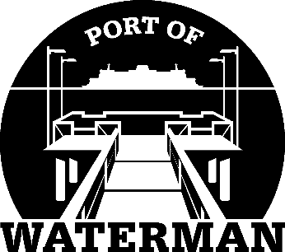

**Port of Waterman Meeting Agenda**

**September 16, 2025**

* Review/Approve Agenda
* Review/Approve Prior Meeting Minutes
* Review/Approve Auditor’s Report
* Review Financial Statement

**Old Business:**

* Web Site Update
* Maintenance Update

**New Business:**

* Small Ports Conference
* Commissioner District Reports