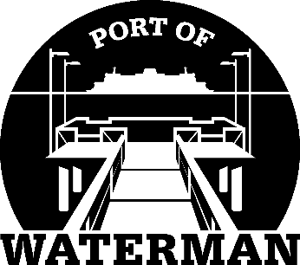

**Port of Waterman Meeting Agenda**

**June 17, 2025**

* Review/Approve Agenda
* Review/Approve Prior Meeting Minutes
* Review/Approve Auditor’s Report
* Review Financial Statement

**Old Business:**

* Web Site Update
* Maintenance Update
* Life Ring/Garbage Cans
* MRSC Roster Membership

**New Business:**

* Annual Report
* Commissioner District Reports
* Fishing Season Prep