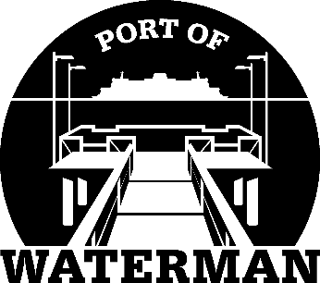

**Port of Waterman Meeting Agenda**

**January 21, 2025**

* Review/Approve Agenda
* Review/Approve Prior Meeting Minutes
* Review/Approve Auditor’s Report
* Review Financial Statement

**Old Business:**

* Maintenance Update
* Tycor Replacement

**New Business:**

* Updating Comprehensive Plan
* Commissioner District Reports