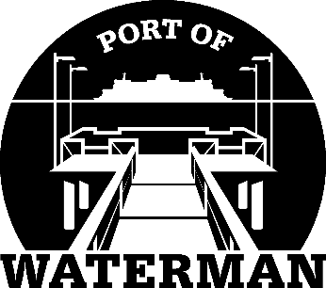

**Port of Waterman Meeting Agenda**

**November 19, 2024**

* Review/Approve Agenda
* Review/Approve Prior Meeting Minutes
* Review/Approve Auditor’s Report
* Review Financial Statement

**Old Business:**

* Maintenance Update
* Tycor Replacement

* Pier Light

**New Business:**

* **2025 Budget/Levy Certificate**
* **Small Port Conference Debrief/Take Aways**
* Commissioner District Reports