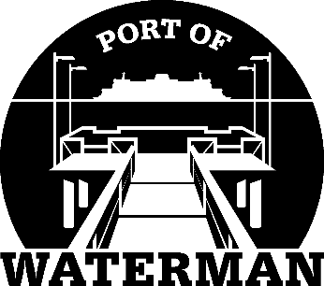

**Port of Waterman Meeting Agenda**

**June 18, 2024**

* Review/Approve Agenda
* Review/Approve Prior Meeting Minutes
* Review/Approve Auditor’s Report
* Review Financial Statement

**Old Business:**

* Maintenance Update
* Tycor Replacement
* IT Support/Cameras
* New Camera
* New Project Ideas - County House on Wynn Jones

**New Business:**

* 2024 Crab Season Preperation
* Commissioner District Reports