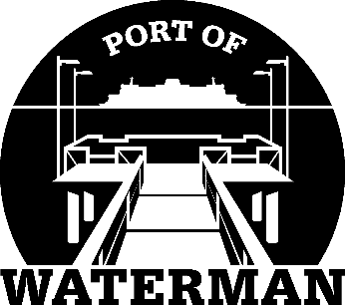

Port of Waterman Meeting Agenda

February 20, 2024

- Review/Approve Agenda

- Review/Approve Prior Meeting Minutes

- Review/Approve Auditor’s Report

- Review Financial Statement

Old Business:

- Maintenance Update

- IT Support/Cameras

- Small Works Roster

New Business:

- New Project Ideas

- Commissioner District Reports

