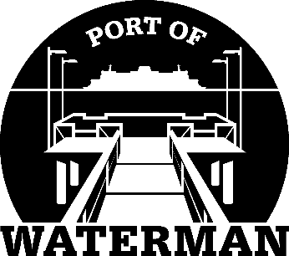

**Port of Waterman Meeting Agenda**

**(This will be a Zoom Meeting. Contact Jeff Reynolds 360-633-0025 for meeting invite)**

**September 19, 2023**

* Review/Approve Agenda
* Review/Approve Prior Meeting Minutes
* Review/Approve Auditor’s Report
* Review Financial Statement

**Old Business:**

* Maintenance Update
* Telephones
* IT Support/Cameras

**New Business:**

* Small Ports Conference
* Commissioner District Reports