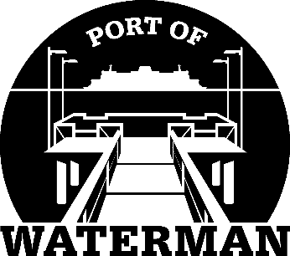

Port of Waterman Meeting Agenda

July 18, 2023

- Review/Approve Agenda

- Review/Approve Prior Meeting Minutes

- Review/Approve Auditor’s Report

- Review Financial Statement

Old Business:

- Maintenance Update

- Telephones

- IT Support/Cameras

- Old Files

- Audit Follow up

New Business:

- Commissioner District Reports

