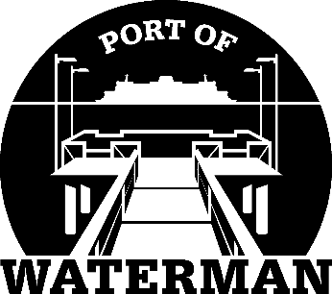

Port of Waterman Meeting Agenda

January 17, 2023

- Review/Approve Agenda

- Review/Approve Prior Meeting Minutes

- Review/Approve Auditor’s Report

- Review Financial Statement

Old Business:

- Maintenance Update (Acoba)

- Extra Patrol Letter

- IT Support/Cameras

- Old Files

New Business:

- Commissioner District Reports

