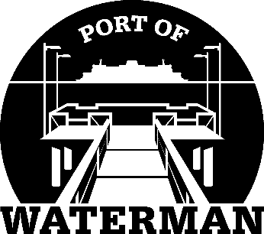

Port of Waterman Meeting Agenda

November 15, 2022

- Review/Approve Agenda

- Review/Approve Prior Meeting Minutes

- Review/Approve Auditor’s Report

- Review Financial Statement

Old Business:

- Maintenance Update (Acoba)

- Speed Bumps

- IT Support/Cameras

New Business:

- Small Ports Conference Takeaways

- All Ports Meeting Minutes Approval

- Small Works Roster Approval

- Commissioner District Reports

