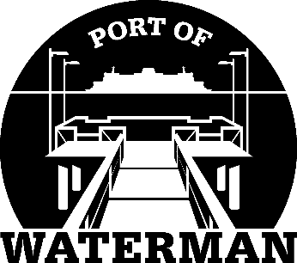

Port of Waterman Meeting Agenda

October 18, 2022

- Review/Approve Agenda

- Review/Approve Prior Meeting Minutes

- Review/Approve Auditor’s Report

- Review Financial Statement

Old Business:

- Maintenance Update (Acoba)

- Speed Bumps

- IT Support/Cameras

New Business:

- Levy Reports/Resolution

- Small Ports Meeting

- Commissioner District Reports

