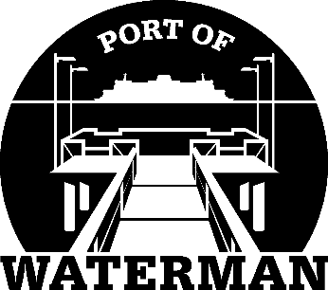

Port of Waterman Meeting Agenda

August 16, 2022

- Review/Approve Agenda

- Review/Approve Prior Meeting Minutes

- Review/Approve Auditor’s Report

- Review Financial Statement

Old Business:

- Maintenance Update (Acoba)

- Change of Financial Statement Yearend (Sheri/Jeff)

- Speed Bumps

- IT Support/Cameras

New Business:

- Commissioner District Reports

