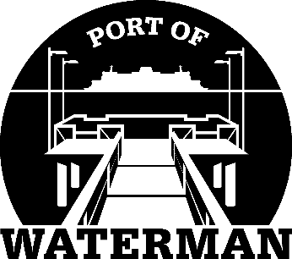

Port of Waterman Meeting Agenda

July 19, 2022

- Review/Approve Agenda

- Review/Approve Prior Meeting Minutes

- Review/Approve Auditor’s Report

- Review Financial Statement

Old Business:

- Maintenance Update (Acoba) – Rail staining?

- Change of Financial Statement Yearend (Sheri/Jeff)

New Business:

- Commissioner District Reports

