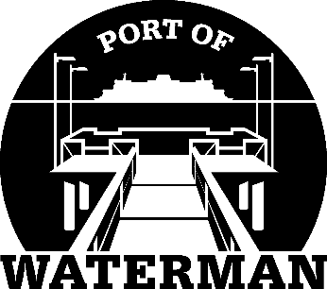

Port of Waterman Meeting Agenda

June 21, 2022

- Review/Approve Agenda

- Review/Approve Prior Meeting Minutes

- Review/Approve Auditor’s Report

- Review Financial Statement

Old Business:

- Maintenance Update (Acoba)

- Poster Board (Guthrie)

- Change of Financial Statement Yearend (Sheri/Jeff)

- Custodial Update (Jeff)

New Business:

- Crab Season Prep

- Commissioner District Reports

