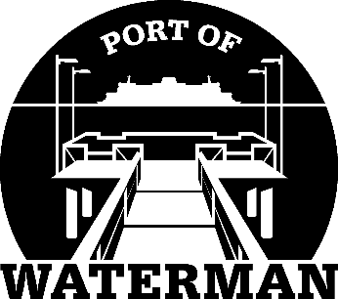

Port of Waterman Meeting Agenda

May 17, 2022

- Review/Approve Agenda

- Review/Approve Prior Meeting Minutes

- Review/Approve Auditor’s Report

- Review Financial Statement

Old Business:

- Maintenance Update (Acoba)

- Poster Board (Guthrie)

New Business:

- 2021 Annual Report Review (McNeal)

- Commissioner District Reports

