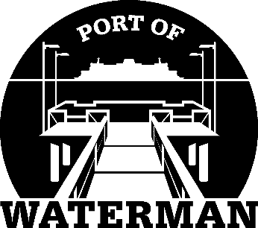

Port of Waterman Meeting Agenda

March 16, 2021

- Review/Approve Agenda

- Review/Approve Prior Meeting Minutes

- Review/Approve Auditor’s Report

- Review Financial Statement

Old Business:

- Maintenance Update (Knapp)

- IT Update (Shoap)

- Official Access to Security Cameras Procedures (Shoap)

- Pigeon Problem (Guthrie)

New Business:

- Commissioner District Reports

