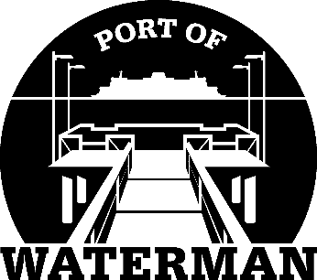

Port of Waterman Meeting Agenda

April 19, 2022

- Review/Approve Agenda

- Review/Approve Prior Meeting Minutes

- Review/Approve Auditor’s Report

- Review Financial Statement

Old Business:

- Maintenance Update (Acoba)

- Poster Board (Guthrie)

New Business:

- Commissioner District Reports

- DNR Lease

