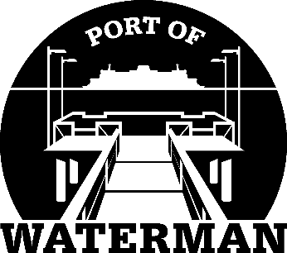

Port of Waterman Meeting Agenda

February 22, 2022

- Review/Approve Agenda

- Review/Approve Prior Meeting Minutes

- Review/Approve Auditor’s Report

- Review Financial Statement

Old Business:

- Maintenance Update (Acoba)

- Derelict Boats

- Poster Board (Guthrie)

- File Cabinet (Guthrie)

New Business:

- Commissioner District Reports

