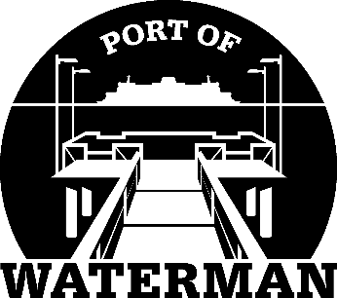

Port of Waterman Meeting Agenda

November 16, 2021

- Review/Approve Agenda

- Oath of Office (Acoba & Guthrie)

- Review/Approve Prior Meeting Minutes

- Review/Approve Auditor’s Report

- Review Financial Statement

Old Business:

- Maintenance Update (Knapp/Acoba) - Parking lot restriping
- Pigeons
- IT Update (Shoap) - Converting to Office 365?

- Redistricting

- Poster Board (Guthrie)

- File Cabinet (Guthrie)

New Business:

- 2022 Budget

- Levy Resolution
- Commissioner District Reports

