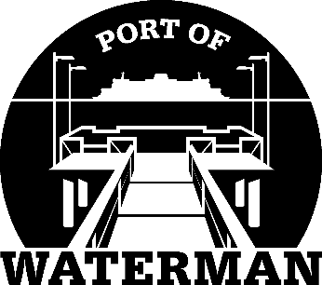

Port of Waterman Meeting Agenda

September 21, 2021

- Review/Approve Agenda

- Review/Approve Prior Meeting Minutes

- Review/Approve Auditor’s Report

- Review Financial Statement

Old Business:

- Maintenance Update (Knapp/Acoba) - Parking lot restriping

- IT Update (Shoap) - Phone Message
- Security Camera
- PC Audit
- Redistricting

- Poster Board (Guthrie)

- Public Records Request Policy (Guthrie)

- File Cabinet (Guthrie)

New Business:

- 2021 Crab Season (Lessons Learned/Recommendations)

- Commissioner District Reports

