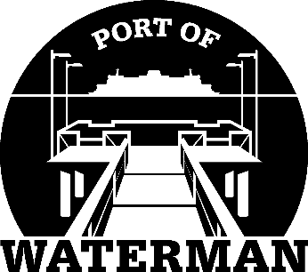

Port of Waterman Meeting Agenda

July 20, 2021

- Review/Approve Agenda

- Review/Approve Prior Meeting Minutes

- Review/Approve Auditor’s Report

- Review Financial Statement

Old Business:

- Maintenance Update (Knapp/Acoba) - Parking lot restriping

- IT Update (Shoap) - Phone Message
- Cyber Checklist for Insurance

- Redistricting

- Poster Board (Guthrie)

- Public Records Request Policy (Guthrie)

- Logo Vests

- Small Ports Meeting in Leavenworth

- File Cabinet

New Business:

- Commissioner District Reports

