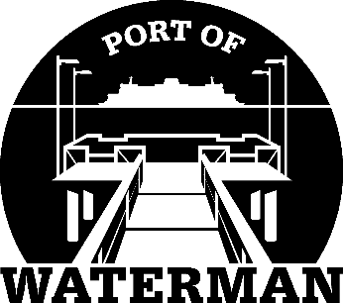

Port of Waterman Meeting Agenda

June 15, 2021

- Review/Approve Agenda

- Review/Approve Prior Meeting Minutes

- Review/Approve Auditor’s Report

- Review Financial Statement

Old Business:

- Maintenance Update (Knapp/Acoba)

- IT Update (Shoap) - Ransomware

- Cyber Checklist for Insurance

- Official Access to Security Cameras Procedures (Shoap)

- Redistricting

- Poster Board (Guthrie)

- Public Records Request Policy (Guthrie)

- Advertising Magnets

- Bank Signature Card Update (McNeal)

- Cyber Check List for Insurance

New Business:

- Fishing Season Preparation

- Commissioner District Reports

