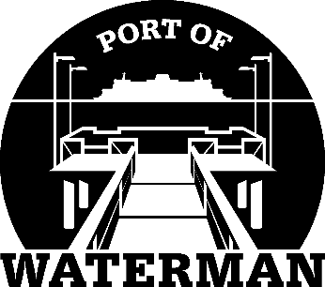

Port of Waterman Meeting Agenda

May 18, 2021

- Review/Approve Agenda

- Review/Approve Prior Meeting Minutes

- Review/Approve Auditor’s Report

- Review Financial Statement

Old Business:

- Maintenance Update (Knapp/Acoba)

- IT Update (Shoap)

- Official Access to Security Cameras Procedures (Shoap)

- Insurance Summary (Shellie Klink)

- Poster Board (Guthrie)

- Public Records Request Policy (Guthrie)

- Advertising Magnets

- Bank Signature Card Update (McNeal)

New Business:

- Approve All Ports Minutes

- Loose Boat Procedures

- Redistricting

- Annual Report (Sheri)

- Commissioner District Reports

