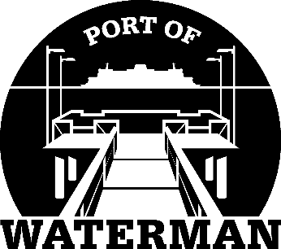

Port of Waterman Meeting Agenda

April 20, 2021

- Review/Approve Agenda

- Review/Approve Prior Meeting Minutes

- Review/Approve Auditor’s Report

- Review Financial Statement

Old Business:

- Maintenance Update (Knapp/Acoba)

- IT Update (Shoap)

- Official Access to Security Cameras Procedures (Shoap)

- Poster Board (Guthrie)

- Public Records Training Update (Guthrie)

- Advertising Magnets (Acoba)

- Bank Signature Card Update (McNeal)

New Business:
- Commissioner District Reports

