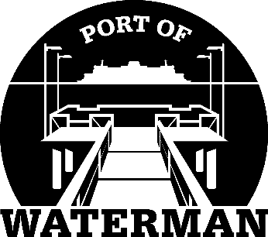

Port of Waterman Meeting Agenda

February 16, 2021

- Review/Approve Agenda

- Review/Approve Prior Meeting Minutes

- Review/Approve Auditor’s Report

- Review Financial Statement

Old Business:

- Commissioner Compton’s Resignation

- Appoint New Commissioner

- Maintenance Work Pending

- Telephone Messages

- Official Access to Security Cameras Procedures

New Business:

- 2020 Elections (Commissioner Guthrie & District #2) – May 17th.

- Appoint Public Records Officer

- Commissioner District Reports

