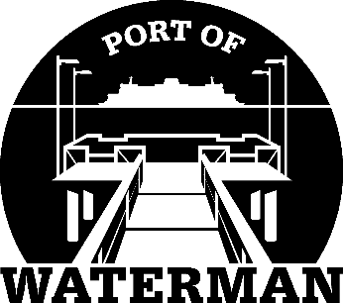

Port of Waterman Meeting Agenda

January 19, 2021

- Review/Approve Agenda

- Review/Approve Prior Meeting Minutes

- Review/Approve Auditor’s Report

- Review Financial Statement

Old Business:

- Maintenance Work Pending

- Telephone Messages

- Life Rings

- Official Access to Security Cameras Procedures

New Business:

- Commissioner Compton’s Resignation

- New Light Fixture Order

- Commissioner District Report

