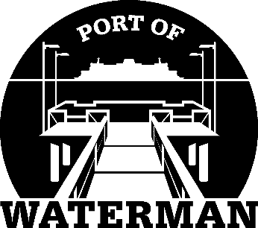

Port of Waterman Meeting Agenda

November 17, 2020

- Review/Approve Agenda

- Review/Approve Prior Meeting Minutes

- Review/Approve Auditor’s Report

- Review Financial Statement

Old Business:

- Maintenance Work Pending

- Poster Holders

- Telephone Messages

- Life Rings

- 2021 Tax Levy Calculation/Approval

New Business:

- 2021 Budget Review/Approval

- Official Access to Security Cameras Procedures

- Commissioner District Report

