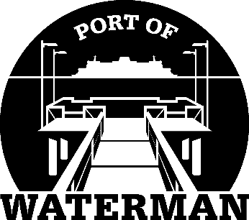

Port of Waterman Meeting Agenda

October 20, 2020

- Review/Approve Agenda

- Review/Approve Prior Meeting Minutes

- Review/Approve Auditor’s Report

- Review Financial Statement

Old Business:

- Security Cameras/Website/Website Management

- Maintenance Work Pending

- Poster Holders

- Telephone Messages

- Life Rings

New Business:

- 2021 Tax Levy Calculation/Approval

- Small Ports Conference

- Commissioner District Reports

