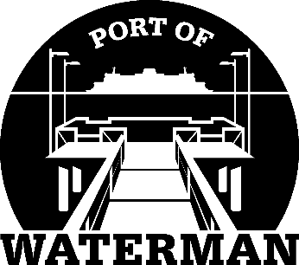

Port of Waterman Meeting Agenda

September 15, 2020

- Review/Approve Agenda

- Review/Approve Prior Meeting Minutes

- Review Approve Auditor’s Report

- Review Financial Statement

Old Business:

- Security Cameras/Website/Website Management

- New Signs

- Maintenance Work Pending

- Neighbor Outreach

- Port’s Historical Documents

- Life Rings

New Business:

- Community Gathering at Pier

- Commissioner District Reports

