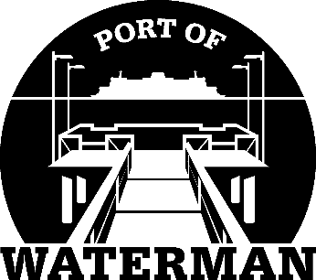

Port of Waterman Meeting Agenda

August 18, 2020

- Review/Approve Prior Meeting Minutes

- Review Approve Auditor’s Report

- Review Financial Statement

Old Business:

- Security Cameras

- Port Phone Number

- New Signs

- Maintenance Contracts

- Neighbor Outreach

- Port’s Historical Documents

New Business:
- Commissioner District Reports

