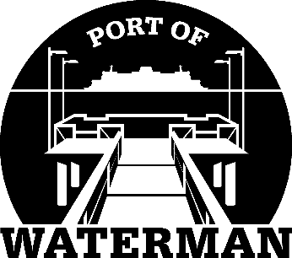

Port of Waterman Meeting Agenda

July 21, 2020

- Review/Approve Prior Meeting Minutes

- Review Approve Auditor’s Report

- Review Financial Statement

Old Business:

- Security Cameras

- Port Phone Number

- New Signs

- Maintenance Contracts

- Crab Season Oversite

- Neighbor Outreach Plan

New Business:
- Commissioner District Reports

